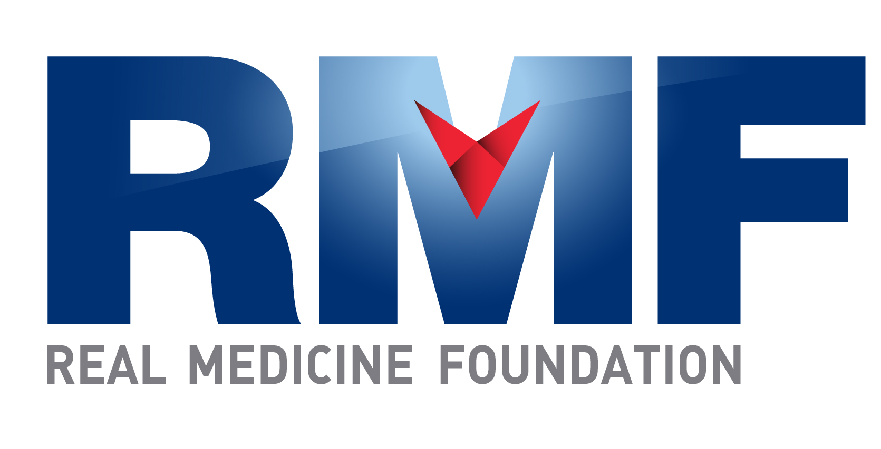

Progress Report: Real Medicine Clinic, Yayawatta,

Tangalle, Sri Lanka

Date: January 28th, 2012 Prepared by: Stephney Minerva Fernando

I. Demographic Information
1. City & Province:
Tangalle, Southern Province, Sri Lanka

2. Organization:

Real Medicine Foundation Sri Lanka

3. Project Title:

Yayawatta Health Clinic

4. Reporting Period:

October 1, 2012 – December 31, 2012

5. Project Location (region & city/town/village):

Seenimodora, Yayawatta, Tangalle, Sri Lanka
6. Target Population:

94 Tsunami affected families and the surrounding communities of four villages with a population of 4,000.
II. Project Information

7. Project Goal:

Provide medical care to Tsunami affected families and the less privileged to help build a healthy community.

8. Project Objectives:

Support the community with free high quality healthcare services

Help to create a healthy community, especially amongst the younger generation

9. Summary of RMF-sponsored activities carried out during the reporting period under project objective (note any changes from original plans):

The clinic was opened 10 days per month to provide free healthcare services to the community of Yayawatta Seenimodara in Tangalle, Sri Lanka, and its surrounding villages and communities of Palapotha, Kadurupokuna & Seenimodara.

10. Results and/or accomplishments achieved during this reporting period:

The clinic was opened for 10 days each month and for the Fourth Quarter of 2012, we saw an average of 20 patients per day with a total of 627 patients treated.

In the month of October, 212 patients treated, with 30% treated for heart diseased/conditions, 20% for viral fever and 20% for viral gastroenteritis.

In the month of November, 211 patients treated, with 50% treated for viral fever, 20% for hypertension and 10% for viral gastroenteritis.
- In the month December, 204 patients treated, with 50% treated for viral fever, 20% for viral gastroenteritis.

11. Impact this project has on the community (who is benefiting and how):

This project benefits two categories of patients; the community of Yayawatta, who had lost their livelihoods and loved ones in the Tsunami and the lower income groups of families that live in the villages and communities around Yayawatta.

12. Number served/number of direct project beneficiaries (for example, average number treated per day or month and if possible, per health condition).
A total of 627 patients were treated at the clinic during this reporting period.

13. Number of indirect project beneficiaries (geographic coverage):

Approximately 4,000

14. If applicable, please list the medical services provided:

The clinic was opened 10 days per month from 7.00 am to 11.00 am.
The most common diseases treated at the clinic for the month of October 2012:

1. Heart Diseases

2. Fever

3. Viral Gastroenteritis

4. Surgical Dressings

5. Joint Pains

6. Worm Infestation

Family Planning Program:

5 mothers received oral contraceptive treatment for the month of October 2012.

The most common diseases treated at the clinic for the month of November 2012:

1. Viral Fever

2. Hypertension

3. Viral Gastroenteritis

4. Ischemic Heart Diseases

5. Joint Pains

Family Planning Program:

Intra muscular injections of Depo-Provera had administered after the long lapse with 4 mothers given the injection. 6 mothers took the oral contraceptive treatment for the month of November 2012.

The most common diseases treated at the clinic for the month of December 2012:

1. Fever & Cough

2. Gastroenteritis

3. Vomiting

4. Burning Epigastria Pain

5. Chest Pain & Hypertension

Family Planning Program:

Intra muscular injections of Depo-Provera had administered after the long lapse with 5 mothers given the injection. 4 mothers took the oral contraceptive treatment for the month of November 2012.

15. Please list the five most common health problems observed within your region. (For Children)

Respiratory Tract Infections

Arthritis

Gastrointestinal Tract Infections

Heart Disease

Skin Diseases

16. Notable project challenges and obstacles:

None

17. If applicable, plans for next reporting period:

18. If applicable, summary of RMF-sponsored medical supply distribution and use:

Monthly Lists of Medicine are attached in Annex 1.

19. Success story(s) highlighting project impact:

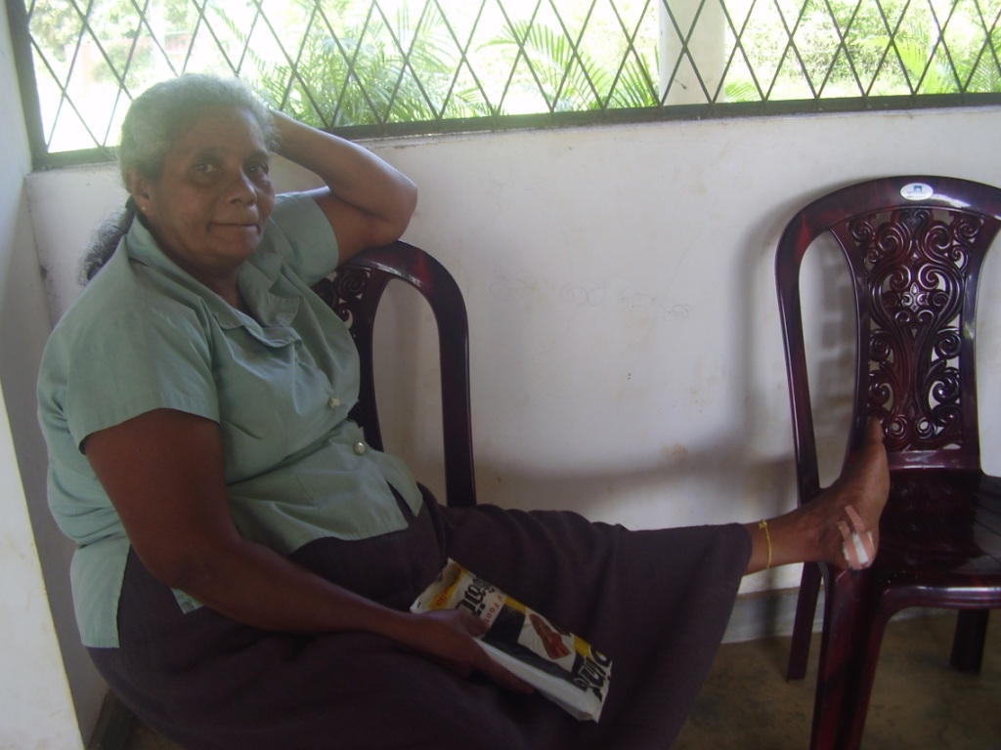

Mrs. Thilaka came to the clinic to have a look at a wound on her left leg that she had had for more than 3 months. Upon examining it was discovered to be a pressure ulcer and she was referred for surgical treatment to the Karapitiya Teaching Hospital in Galle.

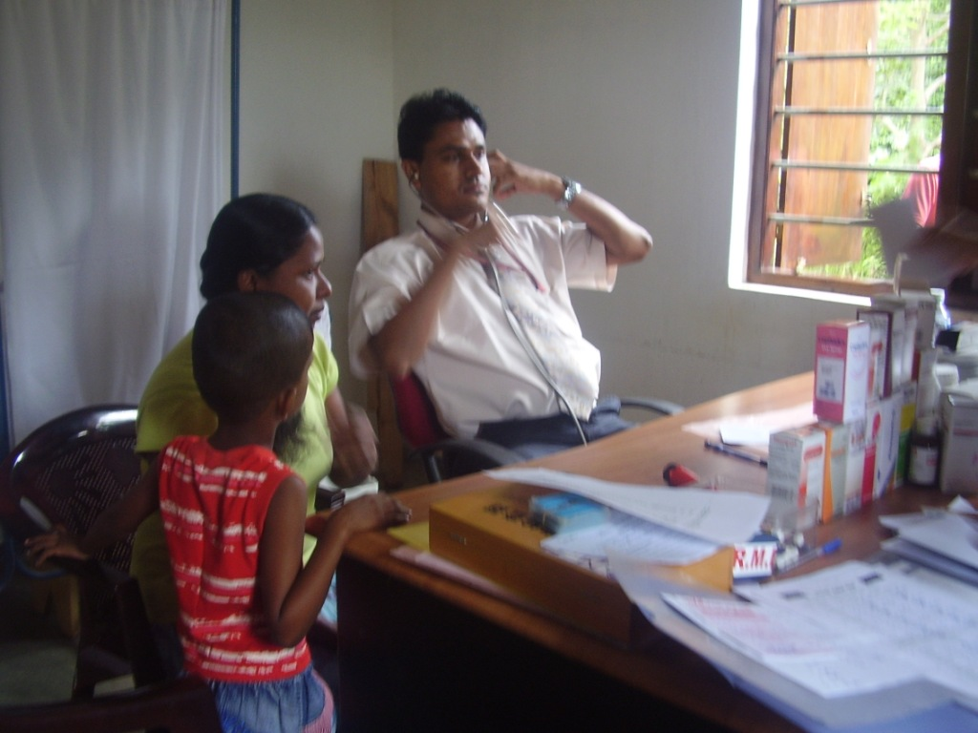

Mrs. Rajika is 27 years old and came to the clinic with a lot of pain in her joints & chest. She was referred her to the Base Hospital Tangalle for an Electrocardiograph, which was revealed to be normal. It was then discovered that the chest pain had started due to the Viral Gastroenteritis and she was given mild Antibiotics & Antacid for 3 weeks. Now she is much better & recovering.

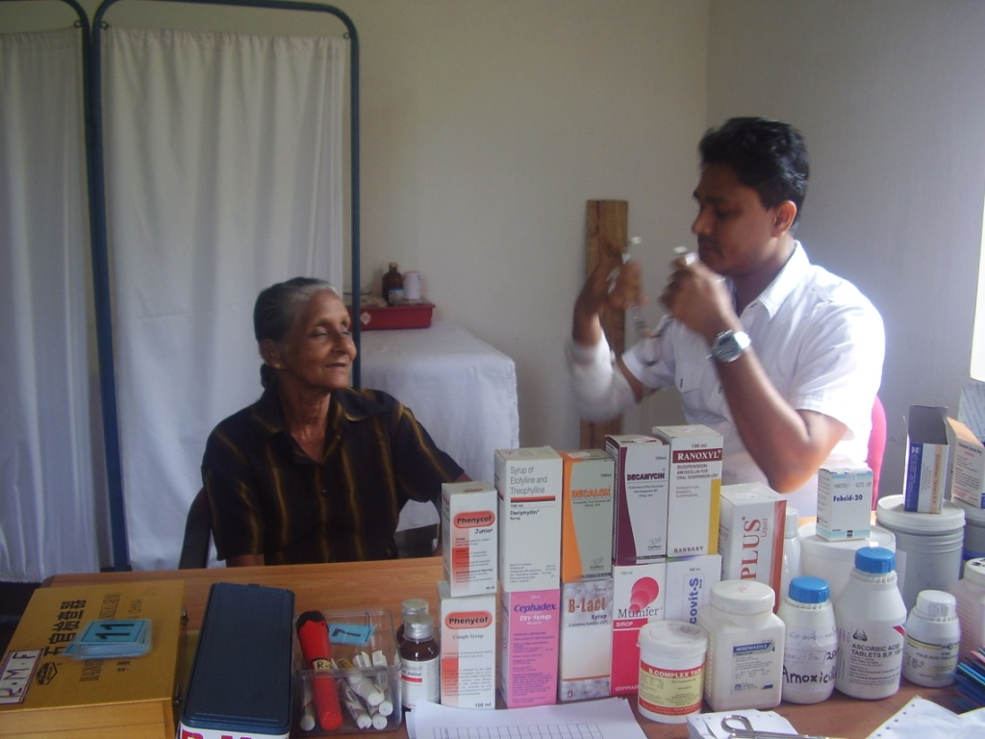

Mrs. Wimala is 68 years old, lives in Yayawatta and came to the clinic with pain & swelling in her joints. She was treated at the clinic for arthritis which lessened the pain but not all the swelling. She was then referred to the Tangalle Base Hospital where it was discovered she was also suffering from knee joint effusion. She is now being treated for Osteoarthritis of her knee joints.

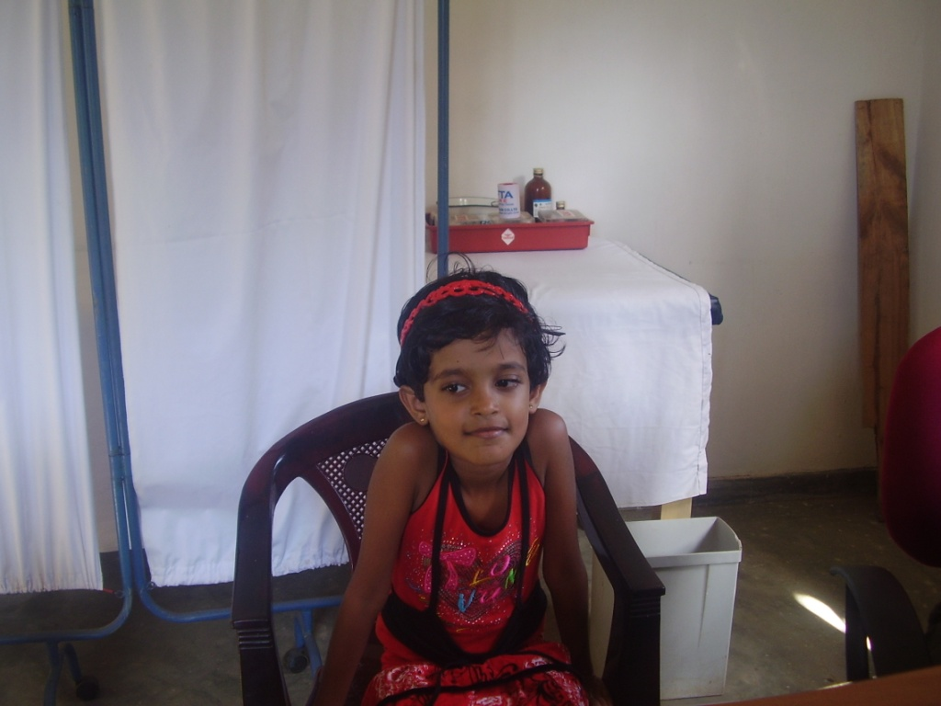

Jani lives in Yayawatta and was brought to the clinic with signs of bleeding of the rectum. She was immediately referred to Karapitiya Teaching Hospital in Galle and underwent an endoscopic test. The surgeons at Karapitya found a lump and polyp. Within 2 days she was operated on and received 5 days of treatment at the hospital. She is now fully recovered and is back in school.

The progressive Note of the Real Medicine Foundation Family

Medical Consultant -- Dr. Chamal Sanjeewa – 3 Children – 2 Daughters – 1 Son
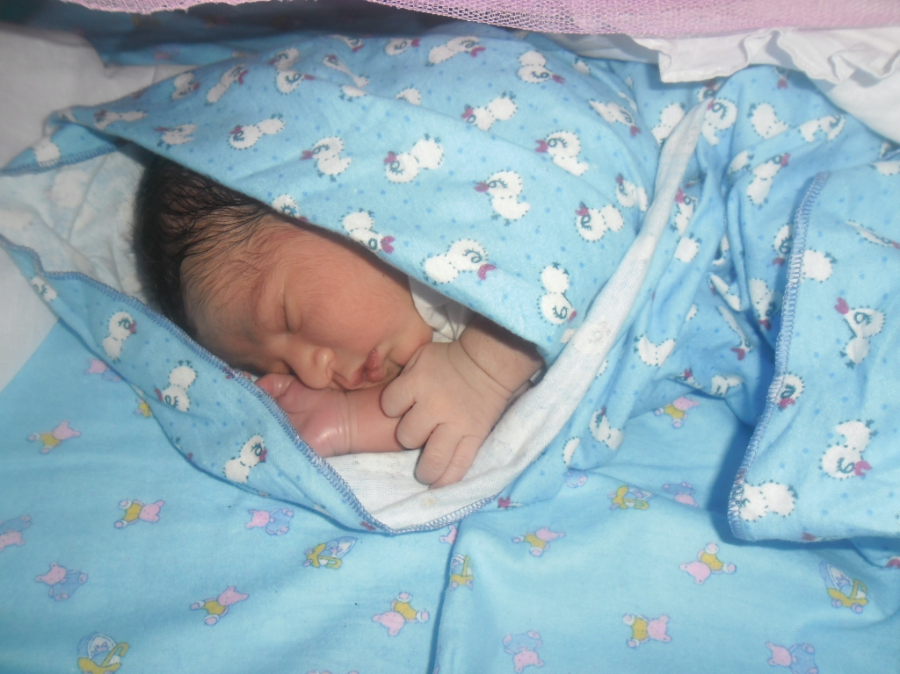
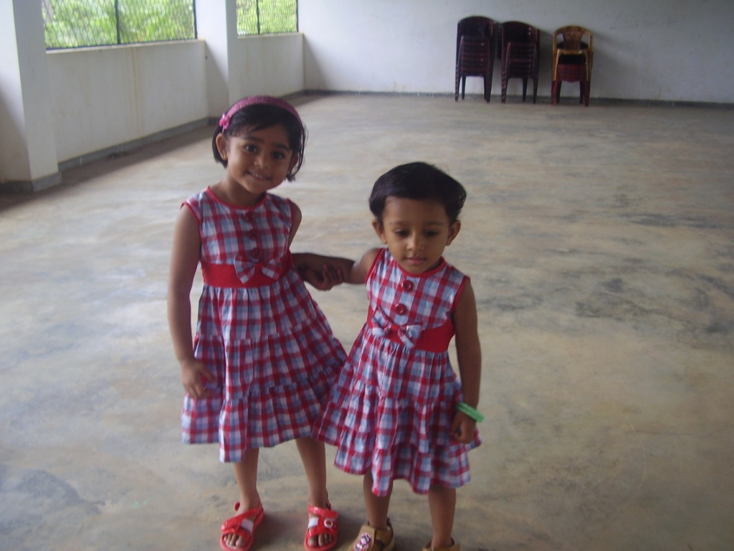
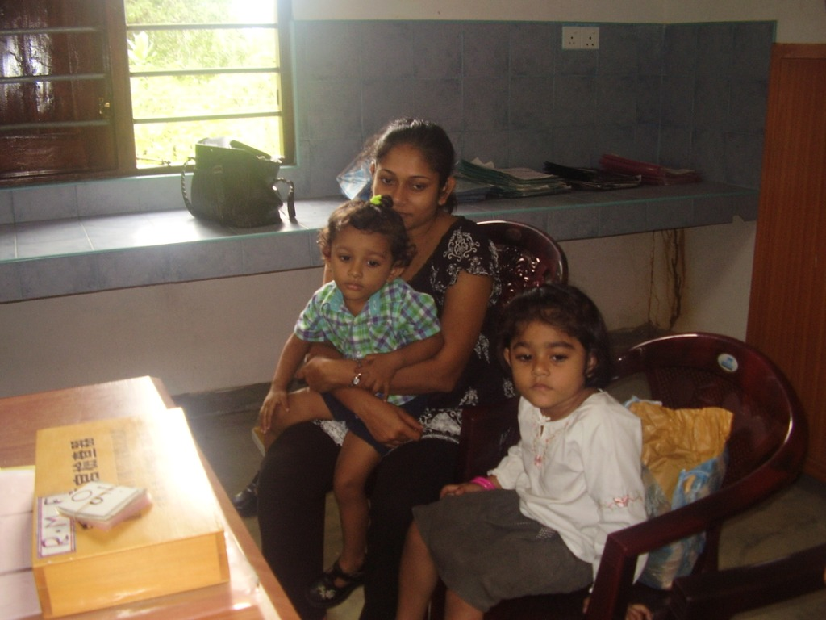

The Accountant – Mr. Nishantha Sandakelum 1 Son
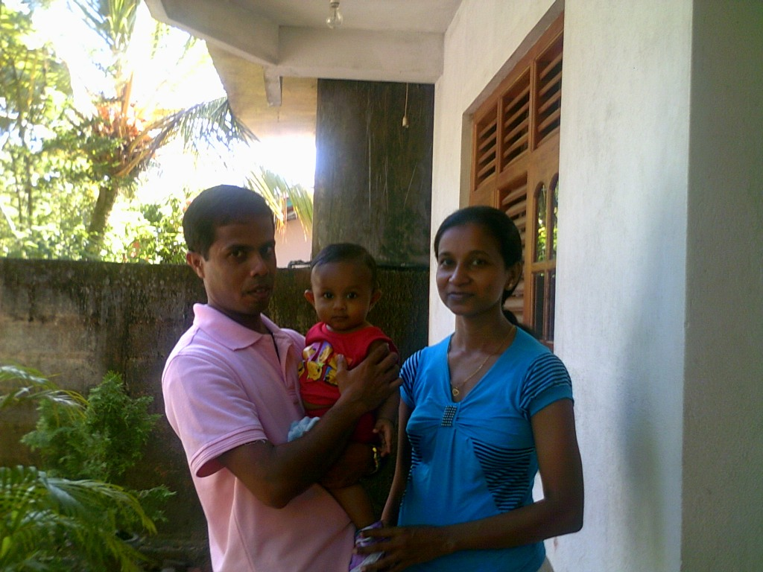
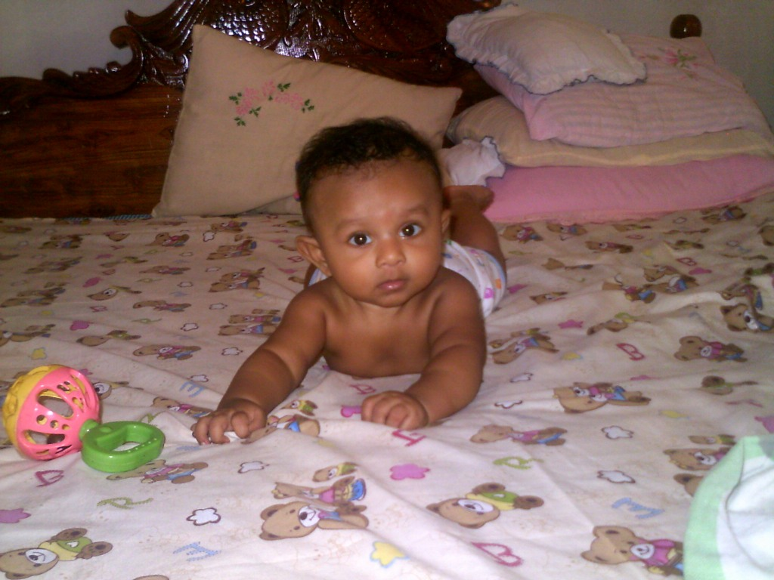

Assistant to Medical Consultant – Mrs. Dimuthu – 2 Children – 1 Daughter – 1 Son
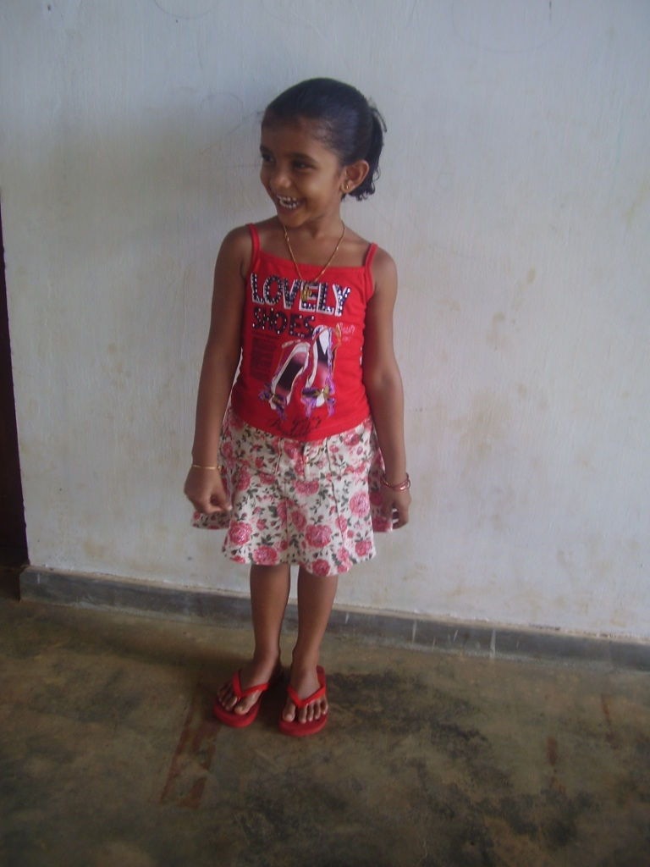
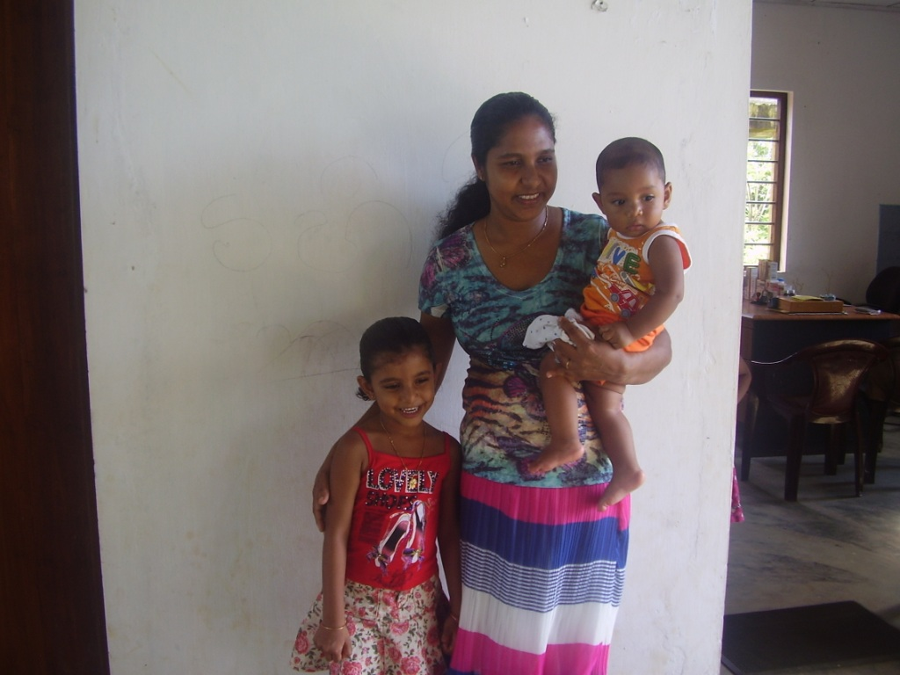
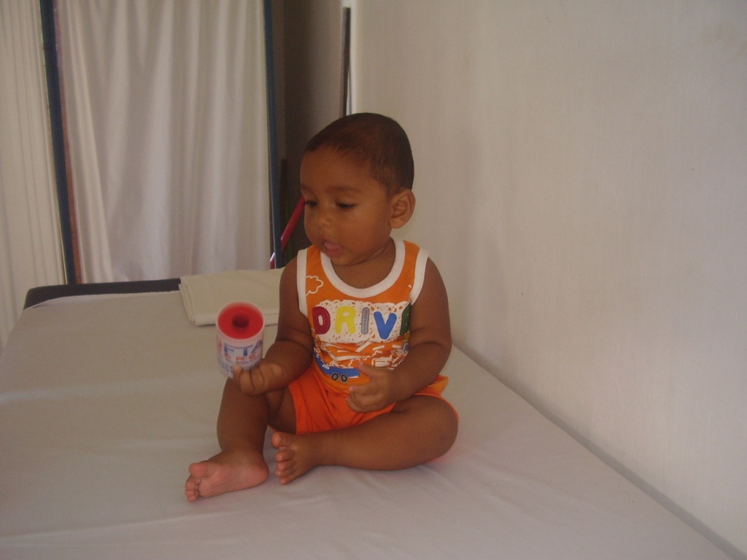

The Helper of the Clinic – Mrs. Lasanthie – 02 Children – 01 Daughter -- 01 Son.
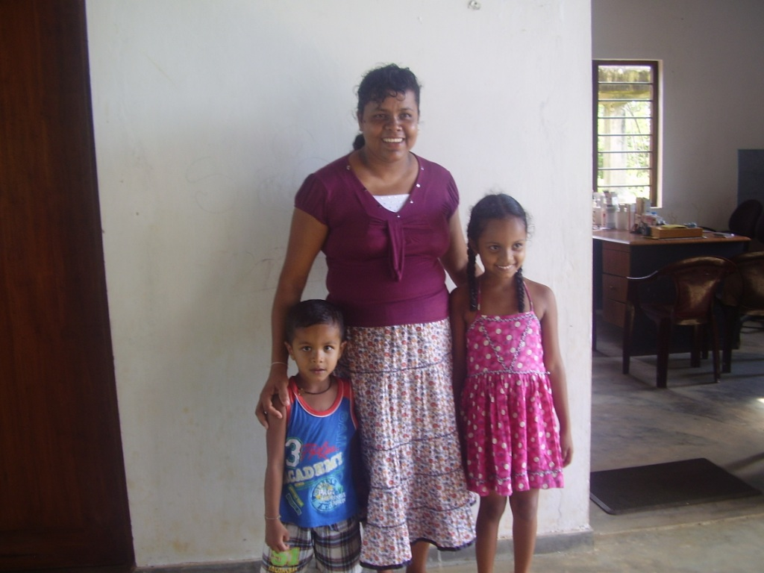
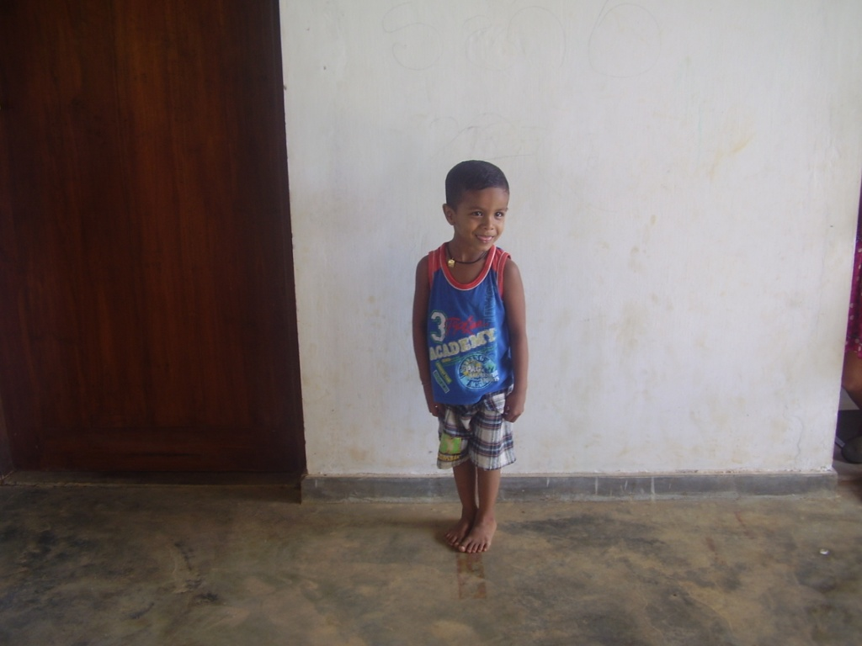
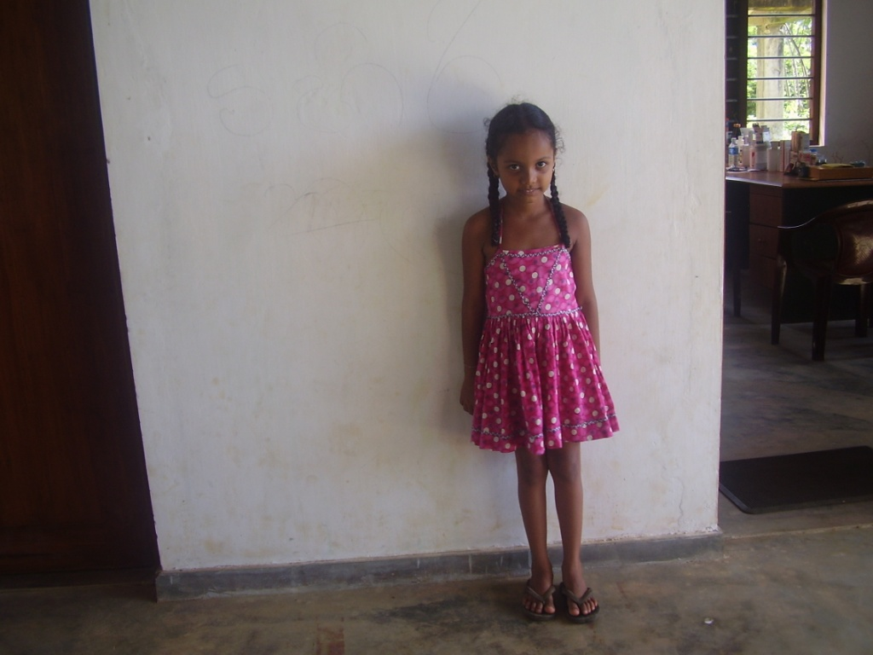

Project Coordinator – Mrs. Stephney Minerva – 6 Grown up Children – 3 Daughters – 3 Sons.

20. Photos of project activities (file attachment is fine):

Photo File is attached.

III. Financial Information
21. Detailed summary of expenditures within each budget category as presented in your funded proposal (file attachment is fine). Please note any changes from plans.
Monthly expenditures of the Clinic of year 2012 October, November and December expenditure sheets are attached with this report.

Thank you!

Please email to:

Martina C. Fuchs, MD PhD

CEO Real Medicine Foundation

11700 National Blvd, Suite #234

Los Angeles, CA 90064

USA

310.820.4502 phone

310.820.9479 fax

Martina.Fuchs@realmedicinefoundation.org

Morbidity Report

Beneficiaries

Place | Year | Month | Patients | Male | Female | Percentage
Real Medicine Clinic | 2012 | OCTOBER | 212 | 97 | 115 | 21.2
 |  | NOVEMBER | 211 | 92 | 119 | 21.1
 |  | DECEMBER | 204 | 94 | 110 | 20.4
TOTAL |  |  | 627 | 283 | 344 | 62.7

Direct Beneficiaries:

Yayawatta | Year | Month | Patients | Male | Female | Average
 | 2012 | OCTOBER | 135 | 62 | 73 | 13.5
 |  | NOVEMBER | 132 | 61 | 71 | 13.2
 |  | DECEMBER | 126 | 57 | 69 | 12.6
 | TOTAL |  | 393 | 180 | 213 | 39.3

Indirect Beneficiaries:

Villages | Year | Month | Patients | Male | Female | Average
Palapotha,  Seenimodara &  Kadurupokuna | 2012 | OCTOBER | 77 | 35 | 42 | 7.7
Palapotha,  Seenimodara &  Kadurupokuna |  | NOVEMBER | 79 | 31 | 48 | 7.9
Palapotha,  Seenimodara &  Kadurupokuna |  | DECEMBER | 78 | 37 | 41 | 7.8
Palapotha,  Seenimodara &  Kadurupokuna | TOTAL |  | 234 | 103 | 131 | 23.4

Disease Chart of the Real Medicine Clinic in Yayawatta, Tangalle, Sri Lanka
For the Months of OCTOBER, NOVEMBER & DECEMBER 2012

Month of OCTOBER 2012

Disease Type | PATIENTS | PERCENTAGE | MALE | FEMALE
01. Heart Diseases | 64 | 30% | 29 | 35
02. Fever | 43 | 20% | 19 | 24
03. Viral Gastroenteritis | 42 | 20% | 21 | 21
04. Surgical Dressings | 32 | 15% | 15 | 17
05. Joint Pains | 21 | 10% | 10 | 11
06. Worm Infestation | 10 | 5% | 03 | 07
TOTAL | 212 |  | 97 | 115

Month of NOVEMBER 2012

Disease Type | PATIENTS | PERCENTAGE | MALE | FEMALE
01. Viral Fever | 105 | 50% | 47 | 58
02. Hypertension | 42 | 20% | 19 | 23
03. Viral Gastroenteritis | 22 | 10% | 08 | 14
04. Ischemic Heart Diseases | 20 | 10% | 08 | 12
05. Joint Pains | 22 | 10% | 10 | 12
TOTAL | 211 |  | 92 | 119

Month of DECEMBER 2012
.
Disease Type | PATIENTS | PERCENTAGE | MALE | FEMALE
1. Viral Fever | 102 | 50% | 47 | 55
2. Viral Gastroenteritis | 41 | 20% | 18 | 23
3. Vomiting | 20 | 10% | 08 | 12
4. Burning Epigastria Pain | 20 | 10% | 09 | 11
5. Chest Pain & Hypertension | 21 | 10% | 12 | 09
TOTAL | 204 |  | 94 | 110

Total Patients number by Village:

Village | OCTOBER | NOVEMBER | DECEMBER | Total
Yayawatta | 135 | 132 | 126 | 393
Palapotha | 30 | 32 | 30 | 92
Kadurupokuna | 28 | 30 | 32 | 90
Seenimodara | 19 | 17 | 16 | 52
Total | 212 | 211 | 204 | 627

Total Patient Numbers by Age& Gender:

By Age | OCTOBER | NOVEMBER | DECEMBER | Total | Male | Female
0 – 05 years | 40 | 43 | 42 | 125 | 55 | 70
06 – 15 years | 50 | 48 | 31 | 129 | 60 | 69
16 – 24 years | 28 | 22 | 28 | 78 | 34 | 44
25 – 49 years | 48 | 52 | 59 | 159 | 70 | 89
50 years+++ | 46 | 46 | 44 | 136 | 64 | 72
Total | 212 | 211 | 204 | 627 | 283 | 344

ANNEX 1

EXPENDITURE FOR MEDICINE FOR THE MONTHS OF OCTOBER, NOVEMBER & DECEMBER 2012.

FOR THE MONTH OF OCTOBER, 2012

NAME | QUANTITY | COST
CAPSULES & TABLETS
01. Amoxicilline(250mgs.) | 300 | Rs.1,500/=
02. Cloaxicilline(500mgs.) | 300 | Rs.1,800/=
03. Brufen(200mgs.) | 300 | Rs.900/=
04. Dexamethazone (0.5mgs) | 1000 | Rs.520/=
05. Ciprofloaxanin(500mgs.) | 300 | Rs.1,950/=
06. Vitamin C | 1000 | Rs.990/=
07. Cephelexin(250mgs.) | 300 | Rs.1,800/=
08. Diclofenac(50mgs.) | 300 | Rs.450/=
09. Dulcolax | 200 | Rs.750/=
10. Famotedene(20mgs.) | 300 | Rs.450/=
11. Emitpo(Domperidone) | 300 | Rs.750/=
12. Flagyl(Metronidozole 400mgs.) | 200 | Rs.1,600/=
13. Multi Vitamin | 600 | Rs.1,000/=
14. Omeprazole(20mgs.) | 300 | Rs.1,350/=
15. Piriton | 1000 | Rs.165/=
16. Paracitamol | 1000 | Rs.650/=
17. Salbutomol | 1000 | Rs.310/=
18. Augmentin(375mgs.) | 30 | Rs.1,480/=
19. Glicozide(80mgs.) | 200 | Rs.1,350/=
20. Mefanamic Acid | 200 | Rs.300/=
SYRUP
01. Derriphyillin | 06 Bottles | Rs.690/=
02. Becadex | 06 Bottles | Rs.1,080/=
03. Salbutomol | 750mls. | Rs.220/=
04. Piriton | 750mls. | Rs.225/=
05. Paracitamol | 750mls. | Rs.325/=
06. Belcid | 06 Bottles. | Rs.1,110/=
OINMENT & CREAM
01.Betnovate N | 06 Tubes | Rs.840/=
INJECTIONS & OTHERS
01. Mithuri | 06 Packets | Rs.600/=
TOTAL(PAID) |  | Rs.25,155/=

REQUIRED MEDICINE TO REAL MEDICINE CLINIC @ YAYAWATTA
FOR THE MONTH OF NOVEMBER YEAR 2012.
NAME | QUANTITY | COST
CAPSULES & TABLETS
01. Orron | 300 | Rs.2,250/=
02. Buscopam | 300 | Rs.3,000/=
03. Diazepam (0.2mgs.) | 300 | Rs.69/=
04. Dexamethazone (0.5mgs) | 1000 | Rs.520/=
05. Erythromycine(500mgs.) | 300 | Rs.2,970/=
06. Vitamin B Compound | 1000 | Rs.291/=
07. Cephelexin(125mgs.) | 300 | Rs.2,550/=
08. H.C.T(Hydrochlorothiazede) | 200 | Rs.80/=
09. Metformin(500mgs.) | 500 | Rs.1,000/=
10. Mebandazole | 300 | Rs.1,500/=
11. Mebandazole(Endal – 500) | 30 | Rs.900/=
12. Paracitamol | 1000 | Rs.600/=
13. Zinnet(500mgs.) | 30 | Rs.3,270/=
14. Atoruastatin (20mgs.) | 200 | Rs.1,200/=
SYRUP
01. Derriphyillin | 06 Bottles | Rs.690/=
02. Amoxicilline | 06 Bottles | Rs.870/=
03. Fersovite | 06 Bottles | Rs.1,020/=
04. Phenicof(Junior) | 06 Bottles | Rs.642/=
05. Phenicof(Adult) | 06 Bottles | Rs.690/=
06. Mumfer | 06 Bottles. | Rs.1,818/=
07. Cephelexin | 06 Bottles | Rs.846/=
08. Erythromycin | 06 Bottles | Rs.1,980/=
09. Phenagan | 500mls. | Rs.287/=
OINMENT & CREAM
01.Jonac Jel | 06 Tubes | Rs.462/=
02. Mycoral | 06 Tubes | Rs.780/=
03. Soframycin | 06 Tubes | Rs.564/=
04. Chloramphenicol(Eye & Ear Drops) | 06 Bottles | Rs.300/=
INJECTIONS & OTHERS
01. Mithuri | 06 Packets | Rs.600/=
TOTAL (PAID) |  | Rs.31,749/=

MONTH OF DECEMBER YEAR 2012.
NAME | QUANTITY | COST
CAPSULES & TABLETS
01. Amoxicilline(250mgs.) | 300 | Rs.1,500/=
02. Cloaxicilline(500ms.) | 300 | Rs.1,800/=
03. Brufen(200mgs.) | 300 | Rs.240/=
04. Dexamethazone (0.5mgs) | 1000 | Rs.515/=
05. Ciprofloaxanin(500mgs.) | 300 | Rs.1,650/=
06. Calcium Lactate | 200 | Rs.80/=
07. Compound Magnesium(Digene) | 300 | Rs.990/=
08. Derriphilline | 200 | Rs.400/=
09. Diclofenac(50mgs.) | 300 | Rs.300/=
10. Dulcolax(5mgs.) | 200 | Rs.120/=
11. Famotedene | 300 | Rs.270/=
12. Flagyl(Metrpnidozole 400mgs.) | 300 | Rs.2,220/=
13. Zinnet(500mgs.) | 30 | Rs.3,270/=
14. Glicozide(80mgs.) | 200 | Rs.1,740/=
15. Omeprazole | 300 | Rs.1,200/=
16. Piriton(4mgs.) | 1000 | Rs.160/=
17. Prednisilone | 200 | Rs.260=
18. Pyrentin(125mgs.) | 300 | Rs.1,950/=
19. Salbutomol(2mgs.) | 1000 | Rs.150/=
20. Augmentin(375mgs.) | 30 | Rs.1,440/=
21. Dianil | 300 | Rs.930/=
22. Mefanamic Acid | 200 | Rs.200/=
SYRUP
01. Derriphyillin | 06 Bottles | Rs.690/=
02. Amino Plus | 06 Bottles | Rs.330/=
03. Salbutomol | 750mls. | Rs.225/=
04. Piriton | 750mls. | Rs.206/=
05. Paracitamol | 750mls. | Rs.313/=
06. Belcid | 06 Bottles. | Rs.1,188/=
OINMENT & CREAM
01.Jonac Jel | 06 Tubes | Rs.462/=
02. Mycoral | 06 Tubes | Rs.1,020/=
03. Cpolex | 06 Bottles | Rs.210/=
INJECTIONS & OTHERS
01.Depo Provera | 06 Vials | Rs.1,320/=
02 Syringes | 06 | Rs.36/=
TOTAL (NOT PAID) |  | Rs.27,385/=

Clinic Staff Payments | OCTOBER | NOVEMBER | DECEMBER | Total
Clinic Staff Payments | Rs.45,800/= | Rs.45,800/= | Rs.45,800/= | Rs.137,400/=
Medicine | Rs.25,155/= | Rs.31,749/= | Rs.27,385/= | Rs.84,289=
Other Expenses | Rs.840/= | Rs.2,335/= | Rs.807/= | Rs.3,982/=
Photo Copy, Internet | Rs.1,456/= | Rs.1,246/= | Rs.759/= | Rs.3,461/=
Total | Rs.73,251/= | Rs.81,130/= | Rs.74,751/= | Rs.229,132/=

