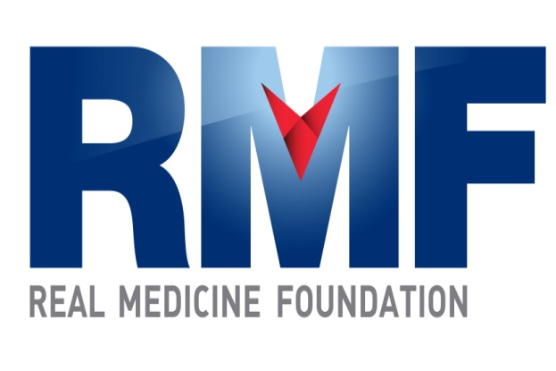

Progress Report: Real Medicine Clinic, Yayawatta,

Tangalle, Sri Lanka

Date: April 29th, 2013 Prepared by: Stephney Minerva Fernando

I. Demographic Information
1. City & Province:
Tangalle, Southern Province, Sri Lanka

2. Organization:

Real Medicine Foundation Sri Lanka

3. Project Title:

Yayawatta Health Clinic

4. Reporting Period:

January 1st, 2013 – March 31st, 2013

5. Project Location (region & city/town/village):

Seenimodera, Yayawatta, Tangalle, Sri Lanka
6. Target Population:

94 Tsunami affected families and the surrounding communities of four villages with a population of 4,000.
II. Project Information

7. Project Goal:

Provide medical care to Tsunami affected families and the less privileged to help build a healthy community.

8. Project Objectives:

Support the community with free high quality healthcare services

Help to create a healthy community, especially amongst the younger generation

9. Summary of RMF-sponsored activities carried out during the reporting period under project objective (note any changes from original plans):

The clinic was opened 10 days per month to provide free healthcare services to the community of Yayawatta, Seenimodera in Tangalle, Sri Lanka, and its surrounding villages and communities of Palapotha, Kadurupokuna & Seenimodera.

10. Results and/or accomplishments achieved during this reporting period:

The clinic was opened for 10 days each month and for the First Quarter of 2013, we saw an average of 20 patients per day with a total of 621 patients treated.

In the month of January, 208 patients were treated, with 70% presenting with respiratory tract infections, and fever. Volatile weather patterns during late December and early January were assumed to be cause for the surge in these conditions.

In the month of February, 205 patients were treated, with 25% for respiratory tract infections and 25% for arthritis.
- In the month of December, 208 patients were treated, with 20% for arthritis, and 10% for gastroenteritis and hypertension.

11. Impact this project has on the community (who is benefiting and how):

This project benefits two categories of patients; the community of Yayawatta who had lost their livelihoods and loved ones in the Tsunami of December 2004, and the lower income groups of families that live in the villages and communities around Yayawatta.

12. Number served/number of direct project beneficiaries (for example, average number treated per day or month and if possible, per health condition).

A total of 621 patients were treated at the clinic during this reporting period.

13. Number of indirect project beneficiaries (geographic coverage):

Approximately 4,000

14. If applicable, please list the medical services provided:
The clinic was opened 10 days per month from 7.00 am to 11.00 am.

The most common diseases treated at the clinic for the month of January 2013:

01. Viral Infections with Fever

02. Respiratory Tract Infections

03. Arthritis

04. Hypertension

05. Asthma

Family Planning Program:

Intra muscular injections of Depo-Provera were administered to 5 mothers and 3 mothers received oral contraceptive treatment.

The diseases treated at the clinic for the month of February 2013:

01. Respiratory Tract Infections

02. Arthritis

03. Viral Fever

04. Hypertension

05. Heart Diseases

06. Skin Diseases

Family Planning Program:

Intra muscular injections of Depo-Provera were administered to 4 mothers and 5 mothers received oral contraceptive treatment.

The diseases treated at the clinic for the month of March 2013:

01. Cough& Cold

02. Rheumatoid Arthritis

03. Viral Gastroenteritis

04. Hypertension

05. skin Diseases

06. Obstetrical Gynecological Diseases

Family Planning Program:

Intra muscular injections of Depo-Provera were administered to 5 mothers and 4 mothers received oral contraceptive treatment.

15. Please list the five most common health problems observed within your region. (For Children)

Respiratory Tract Infections

Arthritis

Gastrointestinal Tract Infections

Heart Disease

Skin Diseases

16. Notable project challenges and obstacles:

None

17. If applicable, plans for next reporting period:

18. If applicable, summary of RMF-sponsored medical supply distribution and use:

Monthly Lists of Medicine are attached in Annex 1.

19. Success story(s) highlighting project impact:

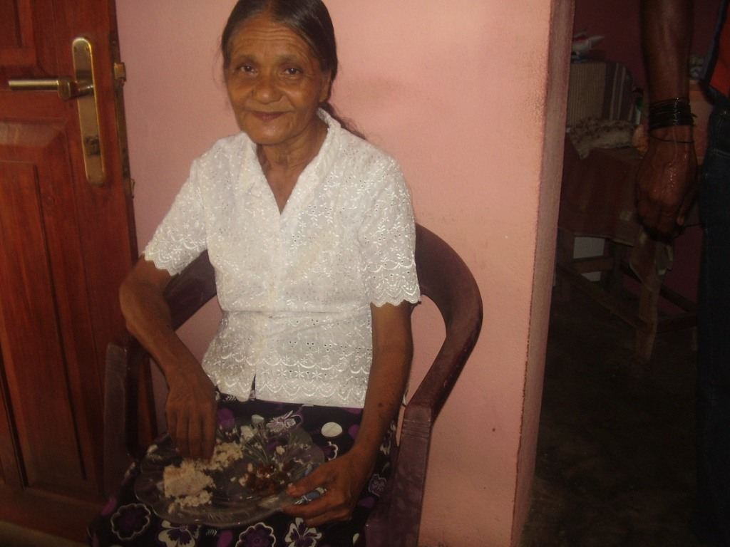

Mrs. Somawathie is 72 years old and lives in Kadurupokuna. She has 6 grown children and lives with her eldest son. Mrs. Somawathie is very feeble and cannot afford to spend much money on her health issues as she does not want to be a burden to her son. She thanks the RMF staff every time she visits our Clinic. She had come to the clinic most recently with a respiratory tract infection and a slight fever. When she was examined we had to refer her to the Tangalle Base Hospital to take x-rays of her chest. She was admitted to the hospital with the diagnosis of bilateral pneumonia, and was started on intravenous antibiotics. She is now recovering at home and her son was given instructions to give her nutritious foods.

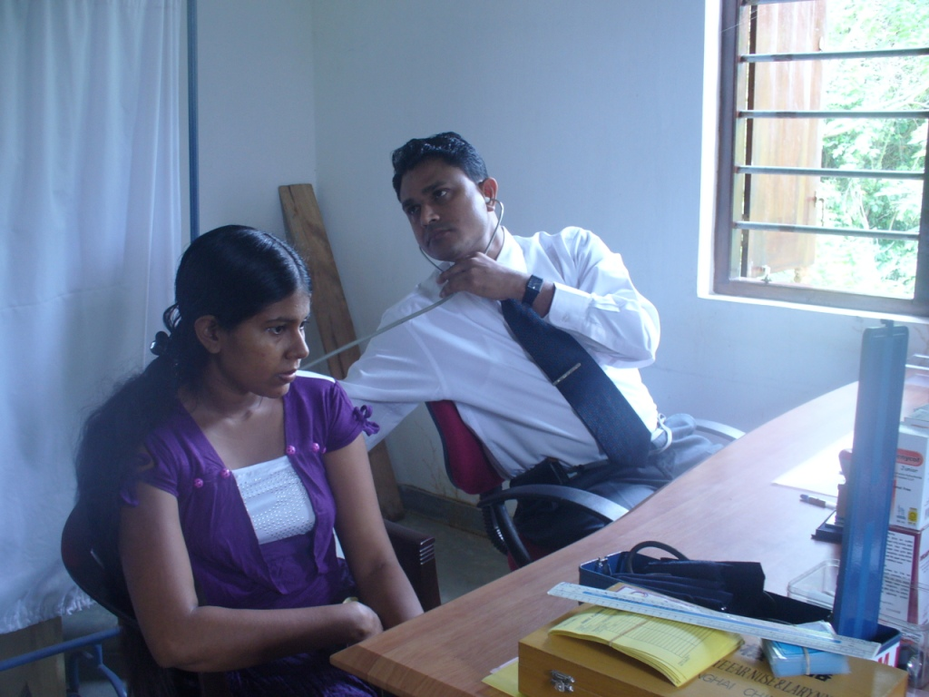

Mrs. Aruni is 25 years old, lives in Yayawatta and is married with 2 children. Mrs. Aruni had come to the Clinic with severe pain & swelling of her joints. Investigation revealed inflammation of the joints and she was referred for further treatment to the Rhomboids Clinic at the Teaching Hospital at Karapitiya in Galle.

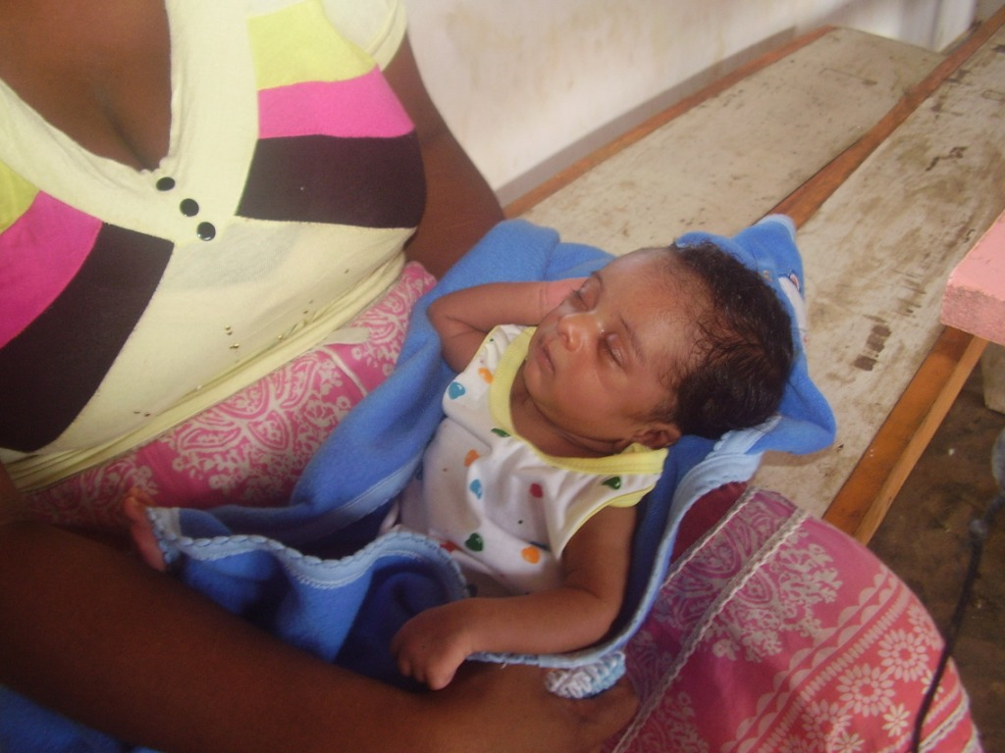
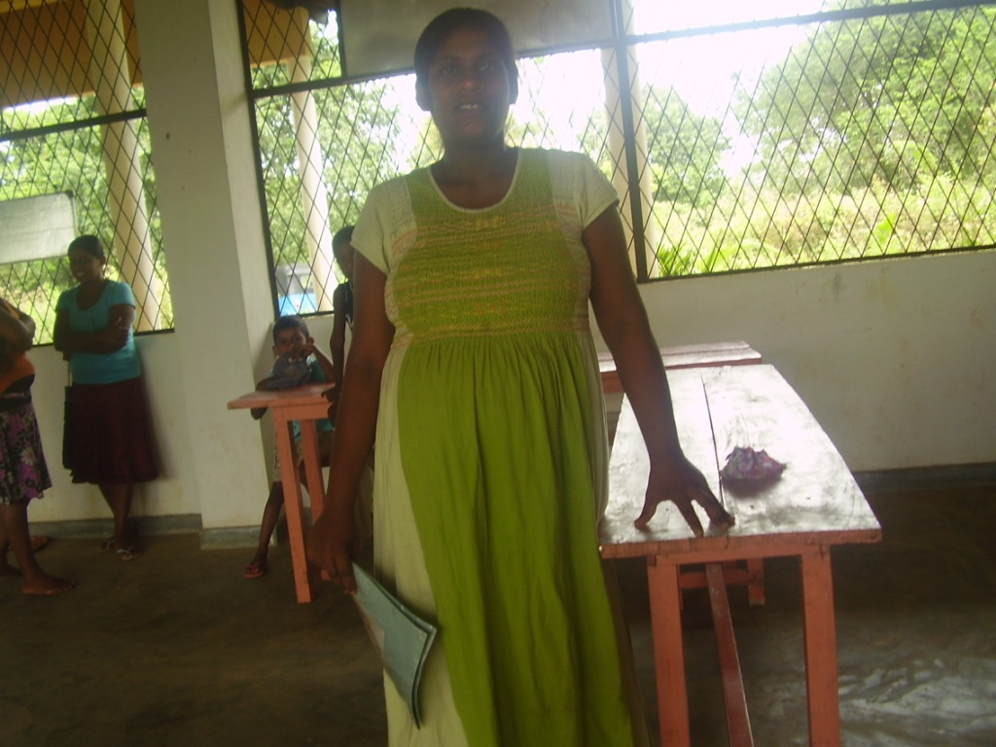

Mrs. Surangika is 29 years old and lives in Yayawatta with her husband and child. The Tsunami of December 2004 had taken away her first baby. Mrs. Surangika now has a healthy son, her second child, who is 5 years old and in school. Mrs. Surangika had been expecting her third child during the first quarter and had been coming to the RMF Clinic regularly to get her blood pressure checked as she had high blood pressure during her entire pregnancy. The baby was born healthy during the second week of March on its due date. Mrs. Surangika is very thankful of RMF’s Health program as it is so helpful to her family as well as the entire community.

20. Photos of project activities (file attachment is fine):

Photo File is attached.

III. Financial Information
21. Detailed summary of expenditures within each budget category as presented in your funded proposal (file attachment is fine). Please note any changes from plans.
Monthly expenditures of the Clinic of year 2013 JANUARY, FEBRUARY & MARCH expenditure sheets are attached with this report.

Morbidity Report

Beneficiaries

Place | Year | Month | Patients | Male | Female | Percentage
Real Medicine Clinic | 2013 | JANUARY | 208 | 92 | 116 | 20.8
 |  | FEBRUARY | 205 | 93 | 112 | 20.5
 |  | MARCH | 208 | 94 | 114 | 20.8
TOTAL |  |  | 621 | 279 | 342 | 62.1

Direct Beneficiaries:

Yayawatta | Year | Month | Patients | Male | Female | Average
 | 2013 | JANUARY | 128 | 53 | 75 | 12.8
 |  | FEBRUARY | 124 | 56 | 68 | 12.4
 |  | MARCH | 132 | 60 | 72 | 13.2
 | TOTAL |  | 384 | 169 | 215 | 38.4

Indirect Beneficiaries:

Villages | Year | Month | Patients | Male | Female | Average
Palapotha,  Seenimodara&  Kadurupokuna | 2013 | JANUARY | 80 | 39 | 41 | 8
Palapotha,  Seenimodara&  Kadurupokuna |  | FEBRUARY | 81 | 37 | 44 | 8.1
Palapotha,  Seenimodara&  Kadurupokuna |  | MARCH | 76 | 34 | 42 | 7.6
Palapotha,  Seenimodara&  Kadurupokuna | TOTAL |  | 237 | 110 | 127 | 23.7

Disease Chart of the Real Medicine Clinic in Yayawatta, Tangalle, Sri Lanka

For the Months of JANUARY, FEBRUARY & MARCH 2013

Month of JANUARY 2013

Disease Type | PATIENTS | PERCENTAGE | MALE | FEMALE
01. Viral Infections with Fever | 104 | 50% | 47 | 57
02. Respiratory Tract Infections | 42 | 20% | 19 | 23
03. Joint Pain (Rheumatoid Arthritis) | 21 | 10% | 09 | 12
04. Hypertension | 20 | 10% | 07 | 13
05. Asthma | 21 | 10% | 10 | 11
TOTAL | 208 |  | 92 | 116

Month of FEBRUARY 2013

Disease Type | PATIENTS | PERCENTAGE | MALE | FEMALE
01. Respiratory Tract Infections | 52 | 25% | 23 | 29
02. Arthritis | 52 | 25% | 26 | 26
03. Viral Infections with Fever | 41 | 20% | 19 | 22
04. Hypertension | 20 | 10% | 08 | 12
05. Heart Diseases | 20 | 10% | 09 | 11
06. Skin Diseases | 20 | 10% | 08 | 12
TOTAL | 205 |  | 93 | 112

Month of MARCH 2013

Disease Type | PATIENTS | PERCENTAGE | MALE | FEMALE
01. Respiratory Tract Infections | 104 | 50% | 49 | 55
02. Arthritis | 42 | 20% | 20 | 22
03. Viral Gastroenteritis | 21 | 10% | 09 | 12
04. Hypertension | 20 | 10% | 08 | 12
05. Skin Diseases | 10 | 05% | 08 | 02
06. Obstetrical/ Gynecological Diseases | 11 | 05% | -- | 11
TOTAL | 208 |  | 94 | 114

Total Patients number by Village:

Village | JANUARY | FEBRUARY | MARCH | Total
Yayawatta | 128 | 124 | 132 | 384
Palapotha | 32 | 29 | 29 | 90
Kadurupokuna | 30 | 32 | 30 | 92
Seenimodara | 18 | 20 | 17 | 55
Total | 208 | 205 | 208 | 621

Total Patient Numbers by Age& Gender:

By Age | JANUARY | FEBRUARY | MARCH | Total | Male | Female
0 – 05 years | 43 | 40 | 45 | 128 | 58 | 70
06 – 15 years | 31 | 48 | 50 | 129 | 60 | 69
16 – 24 years | 28 | 27 | 24 | 79 | 35 | 44
25 – 49 years | 52 | 44 | 52 | 148 | 68 | 80
50 years+++ | 54 | 46 | 37 | 137 | 58 | 79
Total | 208 | 205 | 208 | 621 | 279 | 342

ANNEX 1

EXPENDITURE FOR MEDICINE FOR THE MONTHS OF JANUARY, FEBRUARY & MARCH 2013.

FOR THE MONTH OF JANUARY, 2013
NAME | QUANTITY | COST
CAPSULES & TABLETS
01. Vitamin A & D | 500 | Rs.450/=
02. Cephelexin(250mgs.) | 300 | Rs.2,370/=
03. Emitop(Domperidone 10mgs.) | 300 | Rs.540/=
04. Dexamethazone (0.5mgs) | 1000 | Rs.515/=
05. Folic Acid | 500 | Rs.227/=
06. Iron(Ferrous Sulphate) | 200 | Rs.150/=
07. Multi Vitamin | 500 | Rs.500/=
08. Mebandazole(100mgs.) | 300 | Rs.195/=
09. Mebandazole(ENDAL - 500) | 30 | Rs.900/=
10. Augmentin(375mgs.) | 30 | Rs.1,440/=
11. Atrovastatin(20mgs.) | 200 | Rs.1,200/=
12. Cephelexin(125mgs.) | 300 | Rs.2,550/=
SYRUP
01. Derriphyillin | 06 Bottles | Rs.650/=
02. Amoxicilline | 06 Bottles | Rs.516/=
03. Becadex | 06 Bottles | Rs.1,350/=
04. Fersovite | 06 Bottles | Rs.1,020/=
05. Phenicof(Junior) | 06 Bottles | Rs.642/=
06. Belcid | 06 Bottles | Rs.1,185/=
07. Cephelexin | 06 Bottles | Rs.870/=
08. Erythromycin | 06 Bottles | Rs.1,380/=
09. Domtic | 06 Bottles | Rs.1,560/=
OINMENT & CREAM
01.Betnovate N | 06 Tubes. | Rs.1,560/=
02. Betadine | 300mls. | Rs.350/=
03. Soframycine | 06 Tubes | Rs.564/=
04. Chloramphenicol(Eye & Ear ) | 06 Bottles | Rs.210/=
INJECTIONS & OTHERS
01.Mithuri | 06 Packets | Rs.600/=
02. Envelopes(Medicine) | 1000 | Rs.250/=
TOTAL(PAID) |  | Rs.23,784/=

REQUIRED MEDICINE TO REAL MEDICINE CLINIC @ YAYAWATTA
FOR THE MONTH OF FEBRUARY YEAR 2013.
NAME | QUANTITY | COST
CAPSULES & TABLETS
01. Amoxicilline(250mgs.) | 300 | Rs.750/=
02. Orron | 300 | Rs.2,100/=
03. Brufen(200mgs.) | 300 | Rs.171/=
04. Dexamethazone (0.5mgs) | 1000 | Rs.515/=
05. Ciprofloaxanin (500mgs.) | 300 | Rs.1,650/=
06. Derriphilline (150mgs.) | 200 | Rs.400/=
07. Diclofenac (500mgs.) | 300 | Rs.300/=
08. Erythromycin (500mgs.) | 200 | Rs.2,970/=
09. Mebandazole(ENDAL - 500) | 30 | Rs.1,200/=
10. Famotidine(20mgs.) | 300 | Rs.300/=
11. Glicozide(80mgs.) | 200 | Rs.1,140/=
12. Flagyl(Metronidozole 400mgs.) | 300 | Rs.2,220/=
13. Hydrocothalazide (HCT 50mgs.) | 200 | Rs.100/=
14. Omeprazole (20mgs.) | 300 | Rs.600/=
15. Piriton (4mgs.) | 1000 | Rs.135/=
16. Paracitamol | 1000 | Rs.600/=
18. Vitamin B Compound | 500 | Rs.146/=
19. Zinnet (500mgs.) | 30 | Rs.3,270/=
SYRUP
01. Derriphyillin | 06 Bottles | Rs.720/=
02. Amino Plus | 06 Bottles. | Rs.2,664/=
03. Salbutomol | 750mls. | Rs.232/=
04. Paracitamol | 750mls. | Rs.313/=
05. Phenicof(Junior) | 06 Bottles | Rs.642/=
06. Piriton | 750mls. | Rs.224/=
07. Mumfer | 06 Bottles | Rs.1,818/=
08. Phenagan | 500mls | Rs.220/=
OINMENT & CREAM
01.Betnovate N | 06 Tubes | Rs.1,560/=
02. Jonac Jel | 06 Tubes | Rs.462/=
03. Mycoral | 06 Tubes | Rs.1,020/=
04. Cipolex(Eye & Ear Drops) | 06 Bottles | Rs.450/=
INJECTIONS & OTHERS
01. Mithuri | 06 Packets | Rs.600/=
02. Depo Provera | 06 Vials | Rs.1,320/=
03. Syringes | 06 | Rs.36/=
TOTAL(PAID) |  | Rs.30,848/=

MONTH OF MARCH YEAR 2013.
NAME | QUANTITY | COST
CAPSULES & TABLETS
01. Cloaxicilline(500mgs.) | 300 | Rs.1,800/=
02. Buscopam | 300 | Rs.3,000/=
03. Cephelexin(250mgs.) | 300 | Rs.1,710/=
04. Dexamethazone (0.5mgs) | 1000 | Rs.515/=
05. Calcium Lactate | 200 | Rs.80/=
06. Digene | 200 | Rs.660/=
07. Diazepam(0.2mgs.) | 200 | Rs.30/=
08. Dulcolax (5mgs.) | 300 | Rs.990/=
09. Mebandazole(ENDAL - 500) | 30 | Rs.1,200/=
10. Emitop(Domperidone 10mgs.) | 300 | Rs.540/=
11. Metformin(500mgs.) | 300 | ----------
12. Mebandazole(100mgs.) | 300 | -----------
13. Paracitamol | 1000 | Rs.600/=
14. Prednisilone(5mgs.) | 200 | Rs.280/=
15. Salbutomol | 1000 | Rs,200/=
16. Augmentin(375mgs) | 1000 | Rs.1,440/=
17. Vitamin C(Ascorbic Acid) | 1000 | Rs.750=
18. Atoruastatin(20mgs.) | 300 | Rs.1,950/=
19.Dianil(5mgs.) | 300 | Rs.930/=
20.Mefanamic Acid(25mgs.) | 300 | Rs.300/=
SYRUP
01. Derriphyillin | 06 Bottles | Rs.720/=
02. Amoxicilline | 06 Bottles | Rs.612/=
03. Becadex | 06 Bottles | Rs.1,350/=
04. Phenycof (Adult) | 06 Bottles | Rs.792/=
05. Phenicof(Junior) | 06 Bottles | Rs.642/=
06. Belcid | 06 Bottles | Rs.1,182/=
07. Cephelexin | 06 Bottles | Rs.900/=
08. Erythromycine | 06 Bottles. | Rs.918/=
OINMENT & CREAM
01.Soframycine | 06 Tubes | Rs.564/=
02. Jonac Jel | 06 Tubes | Rs.462/=
03. Chloramphenicol | 06 Bottles | Rs.210/=
INJECTIONS & OTHERS
01. Depo Provera | 06 Vials | Rs.1,350/=
02. Syringes | 06 | Rs.36/=
TOTAL (PAID) |  | Rs.25,963/=

Clinic Staff Payments | JANUARY | FEBRUARY | MARCH | Total
Clinic Staff Payments | Rs.45,800/= | Rs.45,800/= | Rs.45,800/= | Rs.137,400/=
Medicine | Rs.23,784/= | Rs.30,848/= | Rs.25,963/= | Rs.80,595/=
Other Expenses | Rs.2,325/= | Rs.2,334/= | Rs.2,295/= | Rs.6,954/=
Photo Copy, Internet | Rs.1,192/= | Rs.1,246/= | Rs.1,187/= | Rs.3,625/=
Total | Rs.73,101/= | Rs.80,228/= | Rs.75,245/= | Rs.228,574/=

